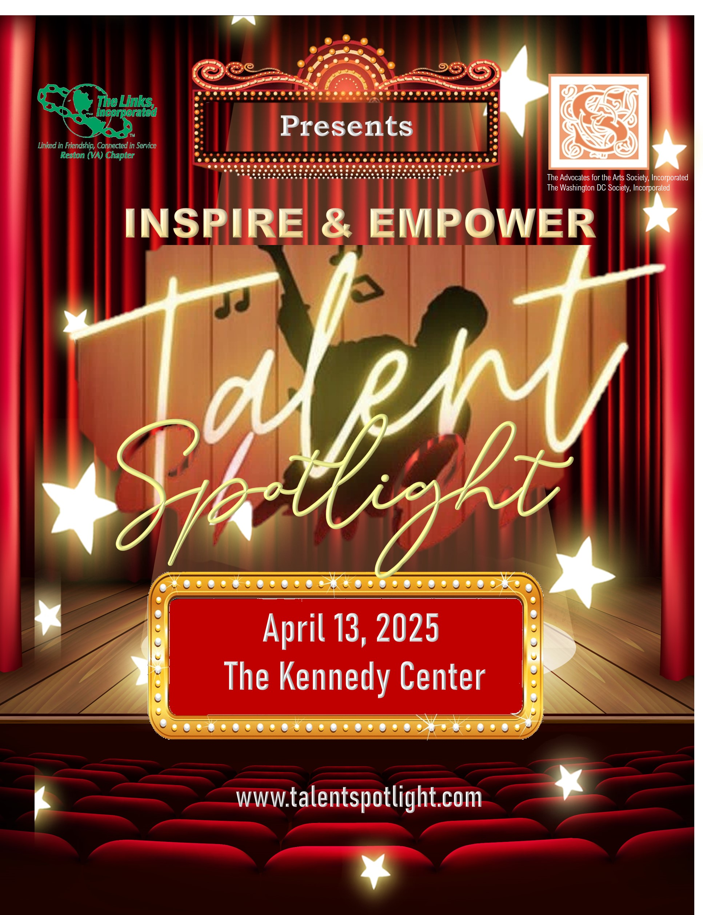

The Reston (VA) Chapter of The Links, Incorporated; Advocates for the Arts Society, Incorporated; and The Society, Incorporated – Washington DC Chapter proudly present the Inspire & Empower Talent Spotlight, a premier showcase of artistic talent taking place on April 13, 2025, at The Kennedy Center in Washington, DC.

This exciting event offers talented high school students the opportunity to perform music, dance, or spoken word in front of industry professionals and a virtual audience. The showcase will be professionally filmed and archived for future reference.

February and March 2025, masterclass workshops will be held for both students and their parents. These workshops will include valuable information on financial aid opportunities and career pathways in the arts. Additionally, parents will have the chance to attend a panel discussion featuring arts professionals, who will share insights on career opportunities, necessary skills, and their experiences in the industry.

Eligibility Requirements:

* You must be a high school senior during the 2024–2025 school year.
* Talent may include (but is not limited to) singing, dancing, instrumental music, and spoken word. Lip-synching is not permitted. Be creative and incorporate the event's theme for inspiration.
* You must complete and sign the Application Form.
* If you are under 18, a parent or legal guardian must sign the Consent Form.
* You must submit a performance video (no longer than three minutes) by December 30, 2024. This video will be used to determine which students advance to perform at The Kennedy Center.
* Selected students will be notified by January 15 2025.
* The final eight selected students will perform at The Kennedy Center and compete for scholarships.

How to Apply:

**Submit your completed application (Permission to use digital and online content/Digital Content Release) and performance video to Showcaseforthearts2025@gmail.com by December 30, 2024.**

**Don’t miss this extraordinary opportunity to showcase your talent and compete for scholarships!**

**Student Application Form   
Please fill out the form below with a signature from your parent/guardian if you are under 18.**

|  |  |
| --- | --- |
| **Name:** | Click or tap here to enter text. |
|  |  |
| **Date of Birth:** | Click or tap here to enter text. |
|  |  |
| **Age:** | Click or tap here to enter text. |
|  |  |
| **Gender:** | Click or tap here to enter text. |
|  |  |
| **Ethnicity:** | Click or tap here to enter text. |
|  |  |
| **Home Address:** | Click or tap here to enter text. |
|  |  |
| **City:** | Click or tap here to enter text. |
|  |  |
| **Daytime Phone Number:** | Click or tap here to enter text. |
|  |  |
| **Evening Phone Number:** | Click or tap here to enter text. |
|  |  |
| **Email Address:** | Click or tap here to enter text. |
|  |  |
| **Mother/Guardian’s Name:** | Click or tap here to enter text. |
|  |  |
| **Father/Guardian’s Name:** | Click or tap here to enter text. |
|  |  |
| **Parents Contact Information:** | Click or tap here to enter text. |
|  |  |
| **Name of High School You Are Attending:** | Click or tap here to enter text. |
|  |  |
| **School City/State/Zip:** | Click or tap here to enter text. |
|  |  |
| **Phone Number:** | Click or tap here to enter text. |
|  |  |
| **Grade:** | Click or tap here to enter text. |

**Indicate Performance Category (Check One):**  
 Music Vocal or  
 Instrumental   
 Dance  
 Spoken Word  
 Visual Art

**Inspire & Empower Talent Spotlight** will be held on **Sunday, April 13, 2025, at the Kenndey Center, Washington DC**.

I hereby certify that all the information I have provided in this application is correct to the best of my knowledge. I confirm that I am currently enrolled in high school and in good academic standing. I also confirm that I will be applying to an accredited two- or four-year college, university, or vocational/technical school.

I authorize **Inspire & Empower Talent Spotlight** producers to verify any of the information contained herein, including after the event.

**Applicant Signature:** Click or tap here to enter text.  
**Date:** Click or tap here to enter text.

**Parent/Guardian Signature:** Click or tap here to enter text.  
**Date:** Click or tap here to enter text.

For Questions, Call:  
Darnell Wise-Lightbourn at **703-786-0786** or Valerie Kilby at **301-643-6653**

Please submit to **Showcaseforthearts2025@gmail.com**

**Permission to Use Digital and   
Online Content**

As a participant in the Inspire & Empower Talent Spotlight Showcase, I understand that my performance may be featured on the following websites:

* The Reston (VA) Chapter of The Links, Incorporated
* Advocates for the Arts Society, Incorporated
* The National Society, Incorporated
* The Society, Incorporated – Washington DC Chapter

I hereby authorize the editors and producers of the Inspire & Empower Talent Spotlight Showcase to copyright, use, and publish my arts submission electronically for showcasing or promotional purposes.

Participant Signature Click or tap here to enter text. Date: Click or tap here to enter text.

Parent Signature: Click or tap here to enter text. Date: Click or tap here to enter text.

**Digital Content Release**

For good and valuable consideration, the receipt of which is hereby acknowledged, I, **[Participant’s Name]**, grant The Society, Incorporated – Washington DC Chapter, Advocates for the Arts, Incorporated, and The Reston (VA) Chapter of The Links, Incorporated (producers of the Inspire & Empower Talent Spotlight) permission to use my likeness in photographs for all publications, including, but not limited to, printed and digital publications related to the Inspire & Empower Talent Spotlight.

I understand and agree that any photograph using my likeness will become the property of the Inspire & Empower Talent Spotlight producers and will not be returned.

I irrevocably authorize the Inspire & Empower Talent Spotlight producers to edit, alter, copy, exhibit, publish, or distribute this content for the purpose of publicizing the programs of The Society, Incorporated – Advocates for the Arts, Washington DC Chapter, and The Reston Chapter of The Links, Incorporated, or for any other lawful purpose.

In addition, I waive the right to inspect or approve the final product, including any written or electronic copy where my likeness appears. I also waive any right to royalties or other compensation related to the use of the photograph.

I hold harmless and release the Inspire & Empower Talent Spotlight producers from all claims, demands, and causes of action that I, my heirs, representatives, executors, administrators, or any other persons acting on my behalf may have in connection with this authorization.

**Student’s Printed Name:** Click or tap here to enter text.  
**Date:** Click or tap here to enter text.  
**Student’s Signature:** Click or tap here to enter text.

**Parent/Guardian Signature (if under 18):** Click or tap here to enter text.  
**Date:** Click or tap here to enter text.

Bottom of Form